test-output folder in IntelliJ

1. Right click on suite.xml file -> More Run/debug -> Modify Run Configurations

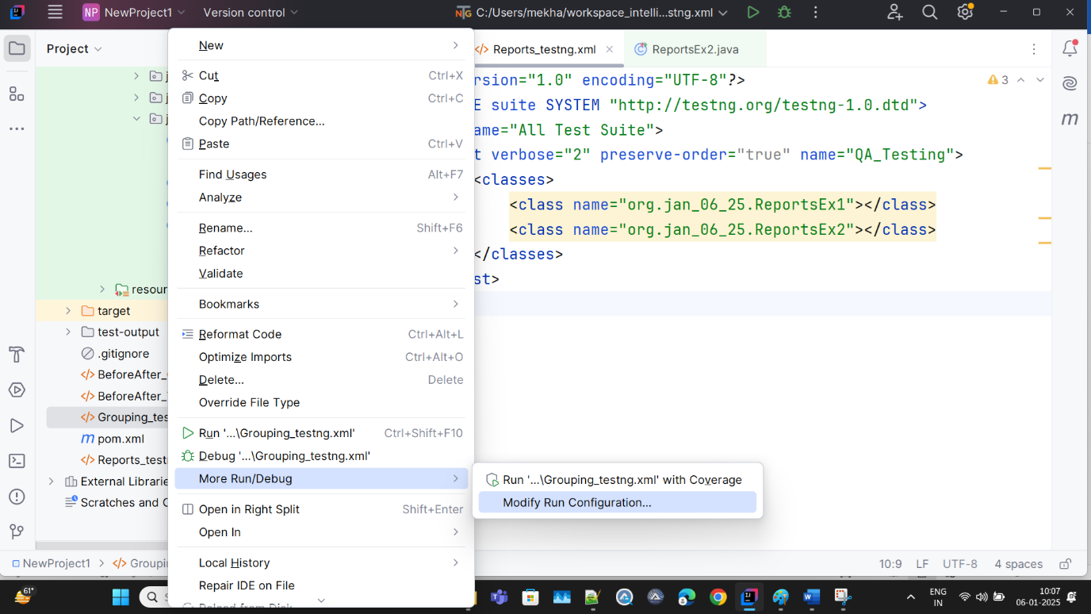

1. Select ‘Suite’ in Test Kind dropdown
2. Mention output directory in your project location as ‘test-output’ folder

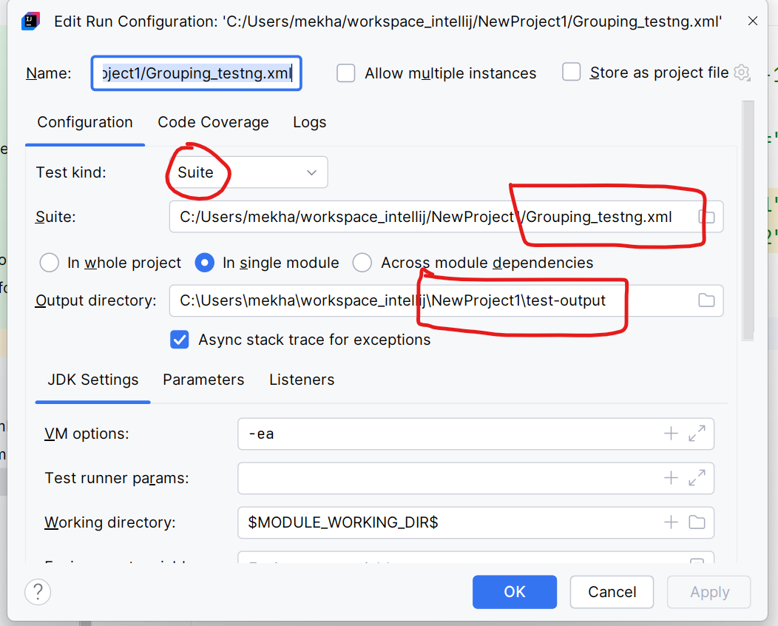

1. Click on Listeners tab in same popup and check the checkbox ‘Use default reporters’

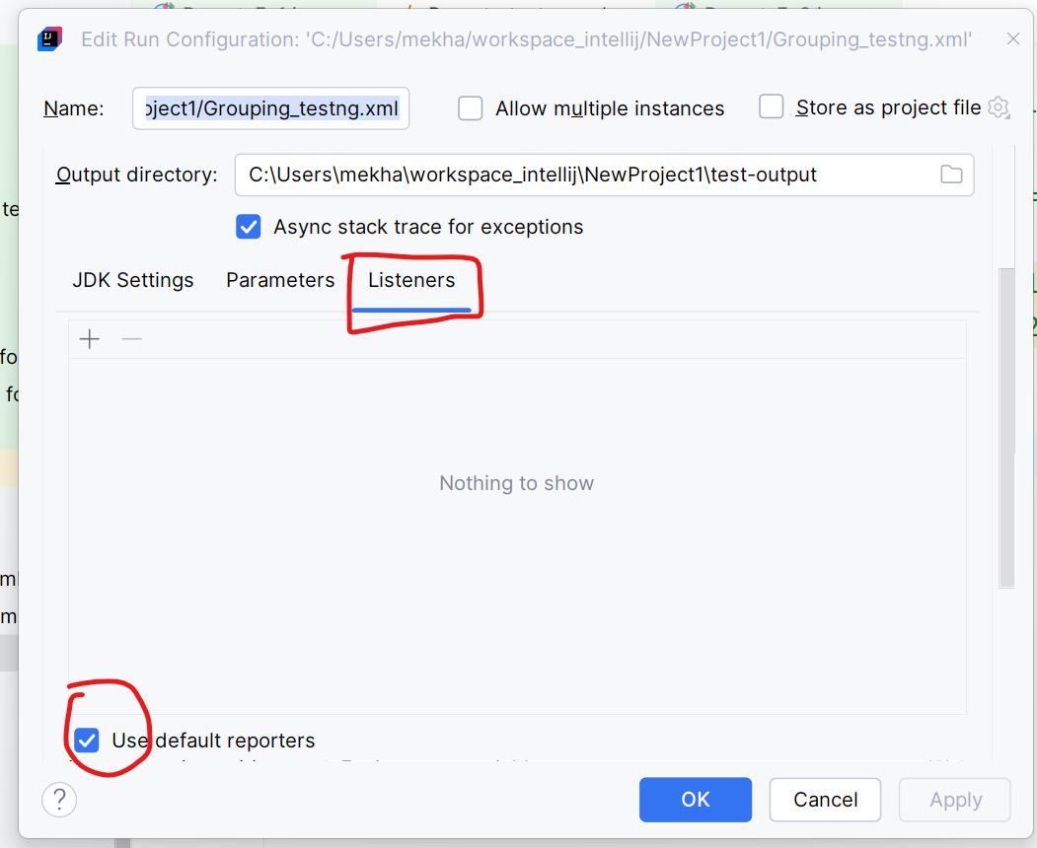

1. Click on Apply and Ok. Popup will be closed.
2. Right click on the suite.xml file
3. Run as TestNG
4. Refresh/Reload the project from disk
5. Observed that test-output folder is created and inside that we can see emailable-report.html file
6. If any test case fails then we will get ‘failed-testng.xml’ file to re-execute only failed test cases.